AI WORKSHEET BASED ON SUBJECT 1 AND SUBJECT 2

Following are question based on case study. Read the problem and answer it accordingly.

Case Study 2: Medical Diagnosis

Problem:

Develop an AI system that can diagnose common medical conditions based on a patient's symptoms. Use Top-down Approach.

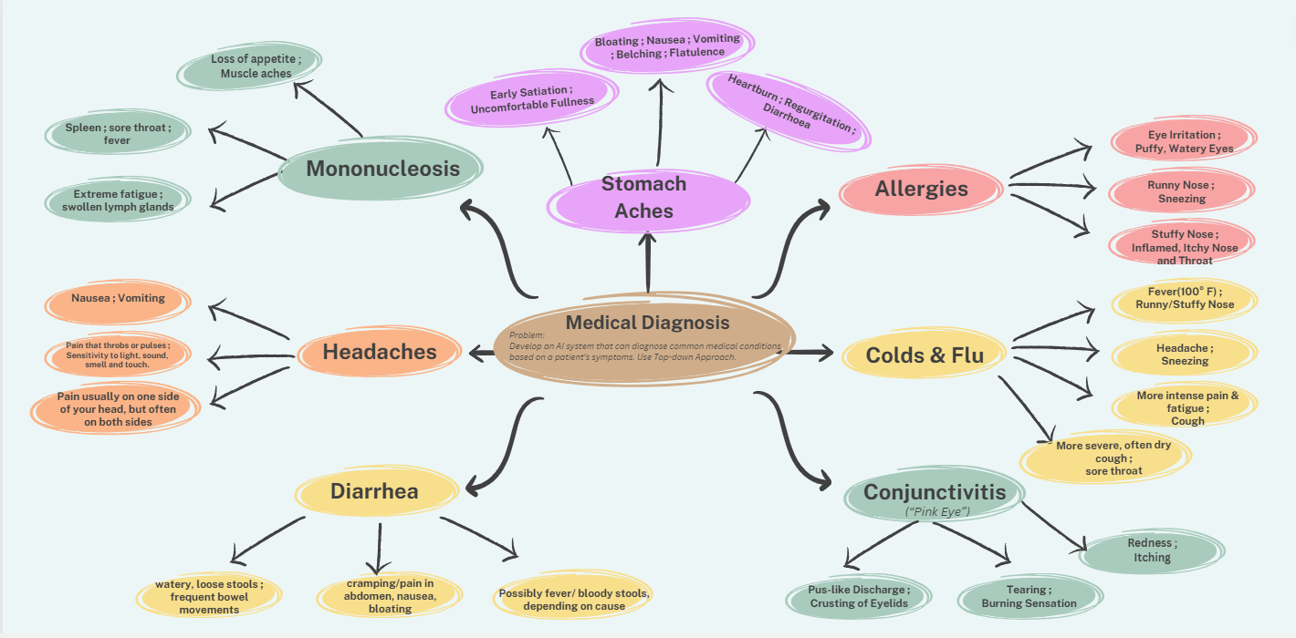

Case Study 3: Face Recognition

Problem:

Develop an AI system that can recognize faces from images and videos. Use Top-down Approach.